**MAD CEP REPORT**

|  |  |  |
| --- | --- | --- |
|  | **Name** | **Roll. No#** |
| 1. | Moiz Ali | 21SW042 |
| 2. | M. Kashan | 21SW110 |
| 3. | Jawad Ali | 21SW138 |

**Real World Problem Identification**

In an increasingly digital environment, gaining quick and accurate access to physical documents remains a significant challenge. Contracts, receipts, educational certificates, and handwritten notes are common examples of essential papers that are kept in physical form. Accessing the information in these documents requires either manually entering the data or organizing the records, both of which are time-consuming and inefficient. Furthermore, managing a significant volume of physical documents is time-consuming, resulting in space concerns, retrieval difficulties, and a greater likelihood of loss or damage.

Another major challenge is the need for data extraction from physical documents for use in various digital applications. Optical Character Recognition (OCR) technology has advanced significantly, yet many individuals and organizations still struggle with easy-to-use solutions for digitizing text from images of documents. Existing solutions may require costly equipment, limiting their accessibility for the average user.

**Proposed Solution**

To address the challenges associated with managing and digitizing physical documents, the Document Scanner: Text Recognizer application proposes a user-friendly, efficient solution capable of converting printed text from physical documents into digital text. This solution leverages advanced Optical Character Recognition (OCR) technology to enable users to scan documents with a mobile device, transforming text in real-time into a searchable and editable format.

**Key features:**

1. **Document Scanning and OCR Processing:** Using the camera on a mobile device or a pre-existing image file, the application captures high-quality images of physical documents. It quickly identifies and extracts printed words.
2. **User-Friendly Interface:** Emphasizing ease of use, the solution will feature a streamlined interface, allowing users of varying technical proficiency to operate the scanner seamlessly. The design will incorporate features such as guided scanning, and easy navigation, helping users get high-quality results without extensive setup or training.
3. **Data Storage and Searchability:** The scanned text can be stored locally, with options for organizing documents by folders, and custom labels. This digital archive is easily searchable, ensuring users can quickly locate specific documents or information within their digitized collection.
4. **Cross-Platform:** The solution will be available across devices, including iOS, and Android. This cross-platform compatibility ensures flexibility for users who may need access to their documents across various devices.

**Responsive UI**

*Provided on the next page.*

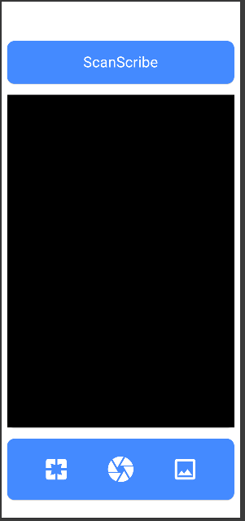 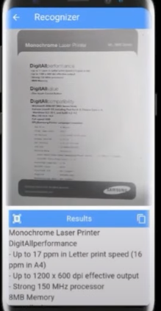 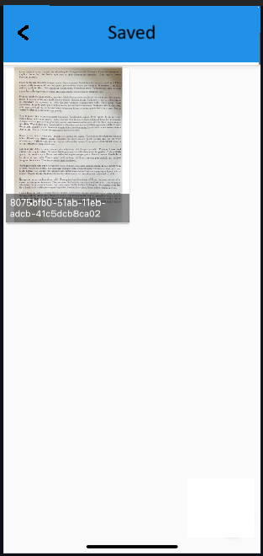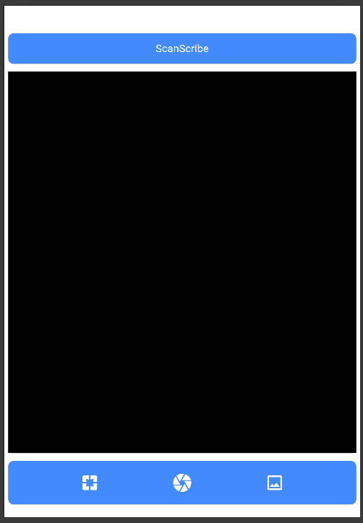

**Data Storage**

For the **Document Scanner: Text Recognizer** project, we propose using **SQLite** as the primary database for local data storage. SQLite is a lightweight, self-contained database engine that operates within the application itself, making it highly suitable for storing user data on local devices without requiring a dedicated database server.

**Justification for SQLite**

1. **Lightweight and Fast:** SQLite’s minimal footprint ensures efficient data storage and retrieval with minimal resource consumption. Unlike traditional server-based databases, SQLite doesn’t require separate server processes, reducing latency and improving the application’s performance on mobile and desktop devices.
2. **Self-Contained and Serverless:** As a serverless database, SQLite enables local storage of documents without needing an external server connection. This is ideal for mobile and offline use, as it allows users to scan, store, and retrieve documents even in environments with limited or no internet connectivity.

**Packages/Plug-ins**

google_mlkit_text_recognition

The **google_mlkit_text_recognition** package provides advanced Optical Character Recognition (OCR) capabilities, enabling the application to accurately recognize text from images. This package was selected for its reliability and flexibility in text recognition, offering High Accuracy in Text Recognition.

camera

The **camera** package allows the application to access the device’s camera, enabling users to capture high-quality images of physical documents for text recognition. The **camera** package is an essential component of the project for Real-Time Image Capture.

permission_handler

The **permission_handler** package manages the permissions required to access device resources, such as the camera and storage, providing a streamlined experience for the user while also ensuring compliance with platform security standards. The justification for using **permission_handler** includes Simplified Permission Management and Enhanced User Privacy.

**Issues and Bugs Encountered and Resolved during Development**

During the development of the **Document Scanner: Text Recognizer** project, we encountered several technical challenges and bugs related to device compatibility, recognition accuracy, and permission handling.

**Issues and the solutions implemented to resolve them**

1. Camera Access and Compatibility Issues: To address these issues, we updated the **camera** settings to support adaptive focus modes and enhanced image resolution. We enabled device-specific configurations, ensuring the app automatically adjusts focus based on the detected device model and environment.
2. Text Recognition Accuracy Issue: Guidelines for capturing high-quality images, such as ensuring adequate lighting and steady camera positioning.
3. Permission Request Errors: To resolve this issue, we implemented the **permission_handler** package to streamline the permissions process across both iOS and Android platforms. We added clear error messages and prompts to guide users in enabling necessary permissions from their device settings if initially denied.
4. Inconsistent Text Formatting: While exporting text, there were issues with formatting. To resolve this, we standardized text formatting during the export process by implementing a formatting layer that converts all text to a consistent font style and orientation. This helped ensure that exported text maintained a clean, and professional appearance.